Task 1

Project: Simple Calculator Web Application Instructions:

1. Define Sprint Goal

2. Prepare Product Backlog: Addition, Subtraction, Multiplication, Division, Input Validation, Error Handling, Responsive UI

3. Break each story into tasks, estimate effort, assign team members

4. Create Trello Sprint Board

5. Draw priority chart and burn-down chart

Deliverables:

● Sprint Goal document

● Sprint Backlog table with tasks, assignments, estimated hours

● Trello board screenshot

● Priority and burn-down charts

● Reflection paragraph

1. Sprint Goal
To develop a fully functional, responsive web-based calculator that performs addition, subtraction, multiplication, and division while ensuring robust input validation and error handling.

2. Product Backlog
ID | User Story | Description | Priority
US1 | Basic Arithmetic | Perform addition, subtraction, multiplication, and division. | High
US2 | Responsive UI | Ensure the calculator works on mobile and desktop screens. | High
US3 | Input Validation | Prevent users from entering invalid characters or symbols. | Medium
US4 | Error Handling | Manage errors like "Division by Zero" without crashing. | Medium
US5 | Basic Functions | Implement a "Clear" (AC) and equals (=) button. | Low

3. Sprint Backlog (Task Breakdown)

Task ID | Task Description | Assigned To | Est. Hours
T1.1 | Setup HTML structure for the calculator grid | Raazia | 2
T1.2 | Implement Addition and Subtraction JavaScript functions | Waheeba | 3
T1.3 | Implement Multiplication and Division JavaScript functions | Waheeba | 3
T2.1 | Apply CSS Flexbox for mobile responsiveness | Raazia | 3
T3.1 | Create input validation to prevent non-numeric entry | Aiza | 2
T4.1 | Write logic to detect and alert for "Division by Zero" | Aiza | 2
T5.1 | Add a "Clear All" (AC) button and reset logic | Waheeba | 1

4. Trello Board

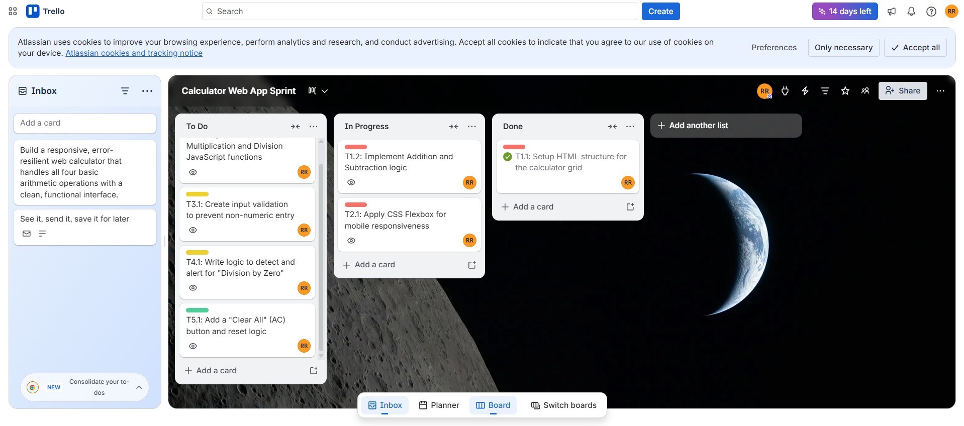

5. Priority and burn-down charts

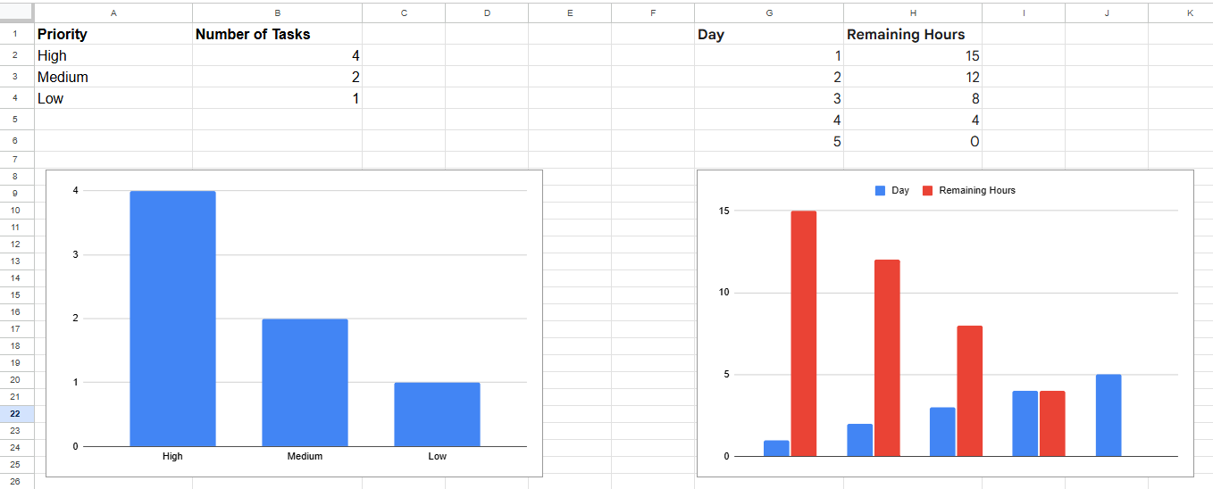

6. Final Reflection

This lab demonstrated how Agile planning transforms a broad project like a 'Calculator Web App' into manageable, prioritized steps. By breaking user stories into specific tasks, we were able to identify that core arithmetic logic (High Priority) must be completed before visual polishing (Low Priority). Using Trello and Burn-down charts provided a clear roadmap, ensuring that time-estimation was realistic and that project bottlenecks were visible before they caused delays

